***************************************************************************************
LEARNING LAB

Principal Investigator: Caitlin M. Fausey, Ph.D.

Email: fausey@uoregon.edu
Mailbox: Psychology Department Mailroom

Undergraduate Researcher Application

***************************************************************************************
Name:
E-mail: Phone Number:
Major:
Year (circle one): Freshman Sophomore Junior Senior Other_____________
Expected Graduation Date:
GPA Overall:
GPA in Major:

Preferred quarter to work in the Learning Lab (circle all that apply):

Fall 2017 Winter 2018 Spring 2018 Summer 2018 Fall 2018 Winter 2018
_______________________________________________________________________________________

SCHEDULE

Are you able to work 10hrs/week at the Learning Lab, on weekdays between the hours of 8am–7pm?

Mark the hours you are available to work in the Learning Lab:
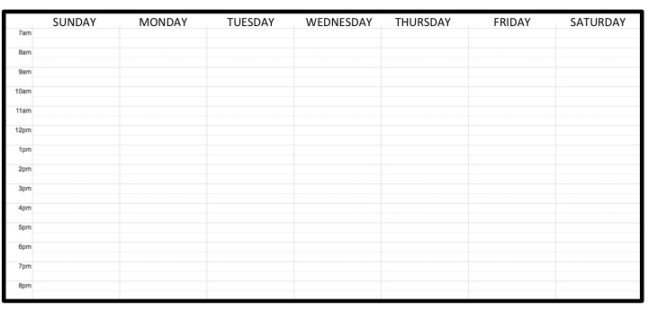
Please attach your course schedule and work schedule (if available).

For the quarter(s) that you circled above:

(a) Which classes you are thinking about taking (if you don’t have your course schedule yet):

(b) Do you have a job? If so, how many hours a week you think you might work?

SKILLS & EXPERIENCES

For each subject, please list the courses you have taken, which quarter, and the grade you earned.
Please also attach a copy of your transcript from UO (unofficial copy / informal is fine.)

Psychology and/or Linguistics

Other science courses

Music courses

What experiences have you had with children between the ages of 6 months and 10 years old? Please indicate the type of experience and the age(s) of the children you have worked with.

What experiences & skills do you have with computer software and/or programming languages?

What experiences (e.g., native language(s), coursework, study abroad, etc.) do you have with language(s) other than English?

What experiences (e.g., coursework, ensembles, own projects, etc.) do you have with musical dictation and/or transcription (i.e., listening to music and notating pitch & rhythmic patterns, tempo, timbre, etc.)?

INTERESTS

Why do you want to work in the Learning Lab?

What are your career goals?

How did you hear about this position?

If you are selected for an interview with someone in the Learning Lab, what is the first question you’d like to ask him/her?

Please provide us with the name and contact (email preferred) of at least one reference. More references (e.g., graduate students, instructors, faculty members and/or current & former employers) are better.

*Requirement: Because our research is with children and sometimes takes place in day cares and preschools subject to state laws, all students involved in research with human subjects may be required to have a criminal check. The criminal check is at no cost to you.

