***************************************************************************************
UO LEARNING LAB

Undergraduate Researcher Application

Principal Investigator: Caitlin M. Fausey, Ph.D. | email: fausey@uoregon.edu | mailbox: Psychology Department Mailroom

***************************************************************************************

Welcome! We’re really glad that you are interested in undergraduate research at UO!
We are excited to meet you and learn about your interests and goals.

Are you curious about early language learning? Are you interested in what objects babies see at home all day long? And/or about the music that families experience together during childhood? How about how babies, toddlers, and grownups play together? We tackle all these questions and more in the UO Learning Lab. Undergraduate researchers are essential members of our team and work together with Dr. Fausey and Ph.D. graduate students. Everyone in the lab – at all levels – is in the business of learning and building skills.

Please note! In our UO Learning Lab, we do not require that undergraduate team members have any specific set of prior experiences. We are excited to build a team with students pursuing all majors, from many lived experiences, all coursework, and more. You do not have to: already have research experience, be a Psychology major, or have aced PSY 301, 302, 303. We will have a conversation about lab needs, your interests and goals, and expectations together and we’ll go from there.

***************************************************************************************

Name:
E-mail:
Phone Number (optional):

How did you hear about this position in the UO Learning Lab?

Are you a UO…. (circle one) First year Sophomore Junior Senior Other_____________
Expected Graduation Date:

Preferred quarter(s) to work in the UO Learning Lab (circle all that apply):
*Please note that some projects in our lab may require a multi-quarter commitment; we can discuss this together.

Winter 2022 Spring 2022 Summer 2022 Fall 2022 Winter 2023

YOUR CURRENT (& future) SCHEDULE

* there are no “right” answers per se. this information helps us understand what lab responsibilities could be a great fit *

Which classes you are currently taking and/or thinking about taking in the future?

Current quarter:

Future quarter(s), if known:

Do you have a job(s)? If so, please tell us about your job responsibilities and schedule (e.g., how many hours per week and what day/time combinations).

Current quarter:

Future quarter(s), if known:

Are you able to work 10 hours every week at the UO Learning Lab (circle one)? Yes / No

Mark the hours you are consistently available to work in the UO Learning Lab (currently):
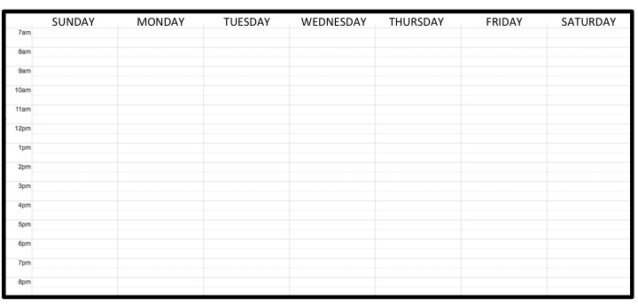
YOUR EXPERIENCES & SKILLS

Major (if known):
Minor/specialization (if applicable):

Please attach a copy of your transcript from UO (unofficial copy / informal is fine).

We’d also like to know about your experiences in the following subject areas. For each subject, please list the courses you have taken, which instructor, and a few words about your experience.

Psychology

Linguistics

Music

Other courses you’d like to tell us about (if any)

What experiences have you had with babies, toddlers, and children (personal and/or professional, if any)? Please indicate the type of experience(s) and the age(s) of the children you have interacted with.

Do you have experiences with computer software and/or programming languages? If so, tell us about these experiences and skills.

Do you have experiences with language(s) in addition to English? If so, tell us about these experiences.

Do you have experiences (e.g., coursework, ensembles, own projects, etc.) with musical dictation and/or transcription (i.e., listening to music and notating pitch & rhythmic patterns, tempo, timbre, etc.)?

Do you have experiences and skills that we haven’t asked about and you’d like to tell us about? If so, please tell us here.

YOUR INTERESTS & GOALS

What do you hope to take away from your experiences working in the UO Learning Lab?
(For example, are you thinking about particular research skills that you’d like to build? Career goals? Build your professional network? Anything you’d like to share with us!)

If you are selected for an interview with someone in the UO Learning Lab, what is the first question you’d like to ask them?

***************************************************************************************

Please tell us with the name and contact information of at least one reference. More references (e.g., graduate students, instructors, faculty members, and/or current & former employers) are better.

*Requirement: Because our research is with children and sometimes takes place in childcare settings and schools subject to state laws, all students involved in research with human subjects may be required to have a criminal background check. This criminal background check is at no cost to you.

